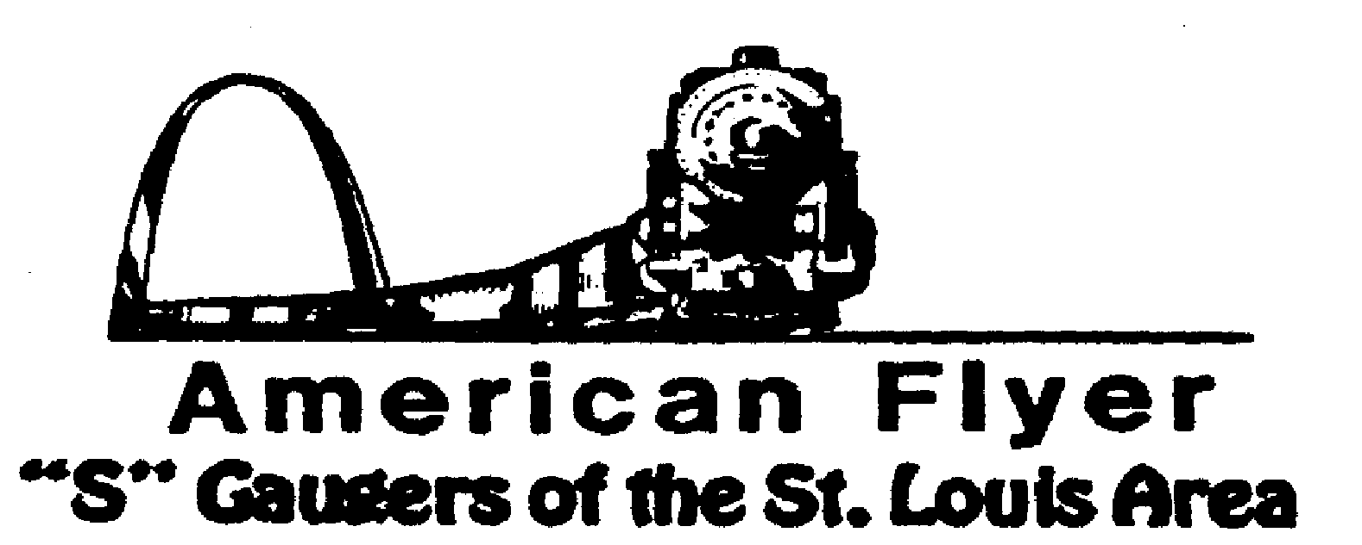

Website: www.trainweb.org/afsgsla/ E-Mail: afsgsla65@gmail.com
_____________________________________________________________________
AFSGSLA (Lack of NEWS) LETTER
November 2020

AFSGSLA Club Events and Related Activities:
As with the last several newsletters, we are combining the planned club events and the other related activities. Although we will not necessarily participate in some of the following events as a club, they are included in this somewhat comprehensive listing for your information. We suggest you keep this newsletter for your future reference and attend our club meetings for full details.
.
Once again not much here.

Actual Scheduled Events

These events are all occurring at the National Museum of Transport coordinated by Andrew Auth

Friday, October 30 we will set up the exterior grey facade building in Orthwein center. If you are able to help on this step that would be appreciated, many of my coworkers have moved on to other jobs.

Monday, November 2nd we will start to set up layer 1.

Tuesday. November 3rd layer 3 finished foam in place.

Wednesday, November 4th hopefully finishing touches, cars, trees, people, buildings.

Monday, November 9th set up double helix in Mezzanine of the Auto building. This should be an easy 1 day project.

NOTE: The museum is closed Monday and Tuesday. The gates will be open on exit side, but entrance side will be closed to detour people, drive on wrong side. Try to make it around 9. I’ll keep door propped open till 9:30 after that I will close, but call me at 3149566746 if you are coming later.

Formerly Scheduled Events that are now Cancelled

Friday, November 6 thru Sunday November 8, 2020: 45th Annual Fall S Fest – hosted by The Badgerland S Gaugers. Postponed to 2021

Saturday, November 2020: Dupo Train Show - Cancelled.

November 2020 AFSGSLA club meeting tentatively hosted by Dave Stone – Cancelled

Saturday and Sunday, Great Train Expo: all shows cancelled until further notice.

Saturday, December 5, 2020 – TCA show at Immanuel Lutheran – rescheduled to December 4, 2021.

What’s been happening?

Friday, September 4, 2020: Club zoom meeting. Gary Brandenburger and Tom Schnur hosted the Club’s Zoom meeting with all interested parties.
Saturday October 17, 2020: Club zoom meeting. Gary Brandenburger and Tom Schnur hosted the Club’s Zoom meeting with all interested parties.

Events Planned for 2021

Friday, September 10, 2021: AFSGSLA club meeting hosted by Cliff and Gail Saxton
The Badgerland S Gaugers have rescheduled the 45th Annual Fall S Fest for November 5th thru 7th 2021. The event will take place at the same location the Four Points Sheraton Airport Hotel.
Saturday, December 4, 2021 – TCA show at Immanuel Lutheran

AFSGSLA’s Club Order of Special Cars:
As always, if you are interested in participating in these club orders, it would be to your advantage to attend the club meetings where details are made available and arrangements are finalized.
---The status of the Special Cars previously ordered have all been delivered.

2020 SFest Cars - There will be two different Milwaukee Road (what else being in Milwaukee) 2 Bay Offset Hoppers with black coal loads. The cars are $55.00 each (plus the registration fee of $18.00) if picked up at the S FEST. These will now be the 2021 SFest cars. NOTE: Badgerland S Gaugers has these cars in stock, so you will not have to wait months, or years, for them.
2021 TCA Convention cars - TCA has announced their 2021 Convention Cars, and they include an American Flyer S Gauge F.H. Hogue Melons Woodside Reefer, a Bald Eagle Grapes Woodside Reefer and a Yosemite Oranges Woodside Reefer. They are very nicely done cars. The club order has been placed. Dave Stone will be notifying the club members who bought cars, when they arrive. They are being shipped to Dave’s home.

This and That
St. Louis Lionel Railroad Club – As previously reported, the building was put up for sale in late May. The option to purchase the building fell through. More information as it becomes available.

Note from Vince Love – Vince has asked me to inform club members that he has all the pictures he took at the last several FSF and they are available. Contact Vince for specific information. It was discussed about putting them in the newsletter, however since some copies are mailed, it would make it too long.

Midwest Money Layout Open House - Sponsored by the Midwest Money Company, on the First Sunday of every month from 11:00 A.M.to 4: P.M. They are located at 5901 Hampton, St. Louis MO just across Holly Hills Street. The layout is rather large, fully developed scenery 3 rail O-Scale layout. This rather large layout may be one of only a very few which can be claimed to be 100% complete. This location is in South St. Louis City, roughly halfway between Chippewa and Gravois. Heard second hand this is temporarily suspended due to the Corona virus. Check before you make the trip.

Mark Twain Hobby Center: Our member John Burke made the initial contact with Mark Twain Hobby about their 10% discount program. We followed up with their Kevin, learned the program details, and enrolled the AFSGSLA members in that program. In summary, it is a 10% discount “across the board” program for all but a very few items they sell. Kevin told us that they limit their advertising through email and that each of you will receive an email with the details of their program.

Special notice from David Stevens: Dave has had it easy recently, but we are hoping to get back to in person club meetings sometime in 2021. We have had a number of our faithful club members who have volunteered to host future meetings. Although our David Stevens is especially pleased with the excellent response to his recent requests, he tells us that we still need club members to volunteer to host club meeting in the future. He states that if you have not hosted a meeting recently---or ever---please carefully consider doing so. It is a great way to “pay your dues” and it really is not much trouble to host a club meeting (the club pays our host a modest fee to offset expenses for refreshments). We have often said (and our hosts have agreed) that there is no surer way of getting your train room shaped up then hosting a club meeting. David Stevens will help you with the details, if you just contact him at Telephone: 314/ 921-1127 or stevens8128@sbcglobal.net.

In Memoria
We were saddened to hear about the death of George Preusser in August. George was a long time member of AFSGSLA, although his health prevented him for attending recent meetings.

Notes from the Newsletter Editor:
Update on my son Anthony. Thanks for all the prayers and wishes for my son Anthony. As has been posted before, Anthony had some serious medical issues this past summer. I am happy to report that he is home after 115 straight days spread over three different hospitals. The good news is that they were able to save his feet. He is slowly recovering, but we will not know if his heart has recovered enough to avoid a heart transplant. Once his feet and legs have healed, he will again have a heart evaluation. Then finally we can see about the kidney transplant.

As always, please email anything you think should be in the newsletter.

Notes from your Co-Coordinators!

TOM SCHNUR
AFSGSLA Co-Coordinator
afsgsla65@gmail.com

RICK ARCHESKI
AFSGSLA Co-Coordinator
rcheski@charter.net

That’s it for now, more later:
GARY MUELLER
AFSGSLA Newsletter Editor
gmatmueller@aol.com

-And remember, “It’s just for the fun of it!”

